2 Analysis

**2.1**

A methodical assessment and assessment of information or data, by breaking it into its segment parts to reveal their interrelationships. Analysis is the most important parts in the business as it helps in dividing the macro problem in micro parts. Analysis is also the most important parts in development as it helps to minimize or divide the work in different small parts.

**2.2 Analysis methodology**

Soft system methodology is used in the analysis as soft system methodology is based on people focus. As, Rental house is the need for the people and focused on people requirements.

**Rich Picture**

Rich picture is used to evaluate the whole situation (project) in a board and open way. It requires all the physical entities. It also helps to evaluate or describe the current issues or problem of the system. It is develop from the soft System methodology.

The current system of renting the house is more time and cost consuming as, client had to visit the each house and had to made contact with different brokers. Rich picture figure is shown below which describing the current system of renting the house.

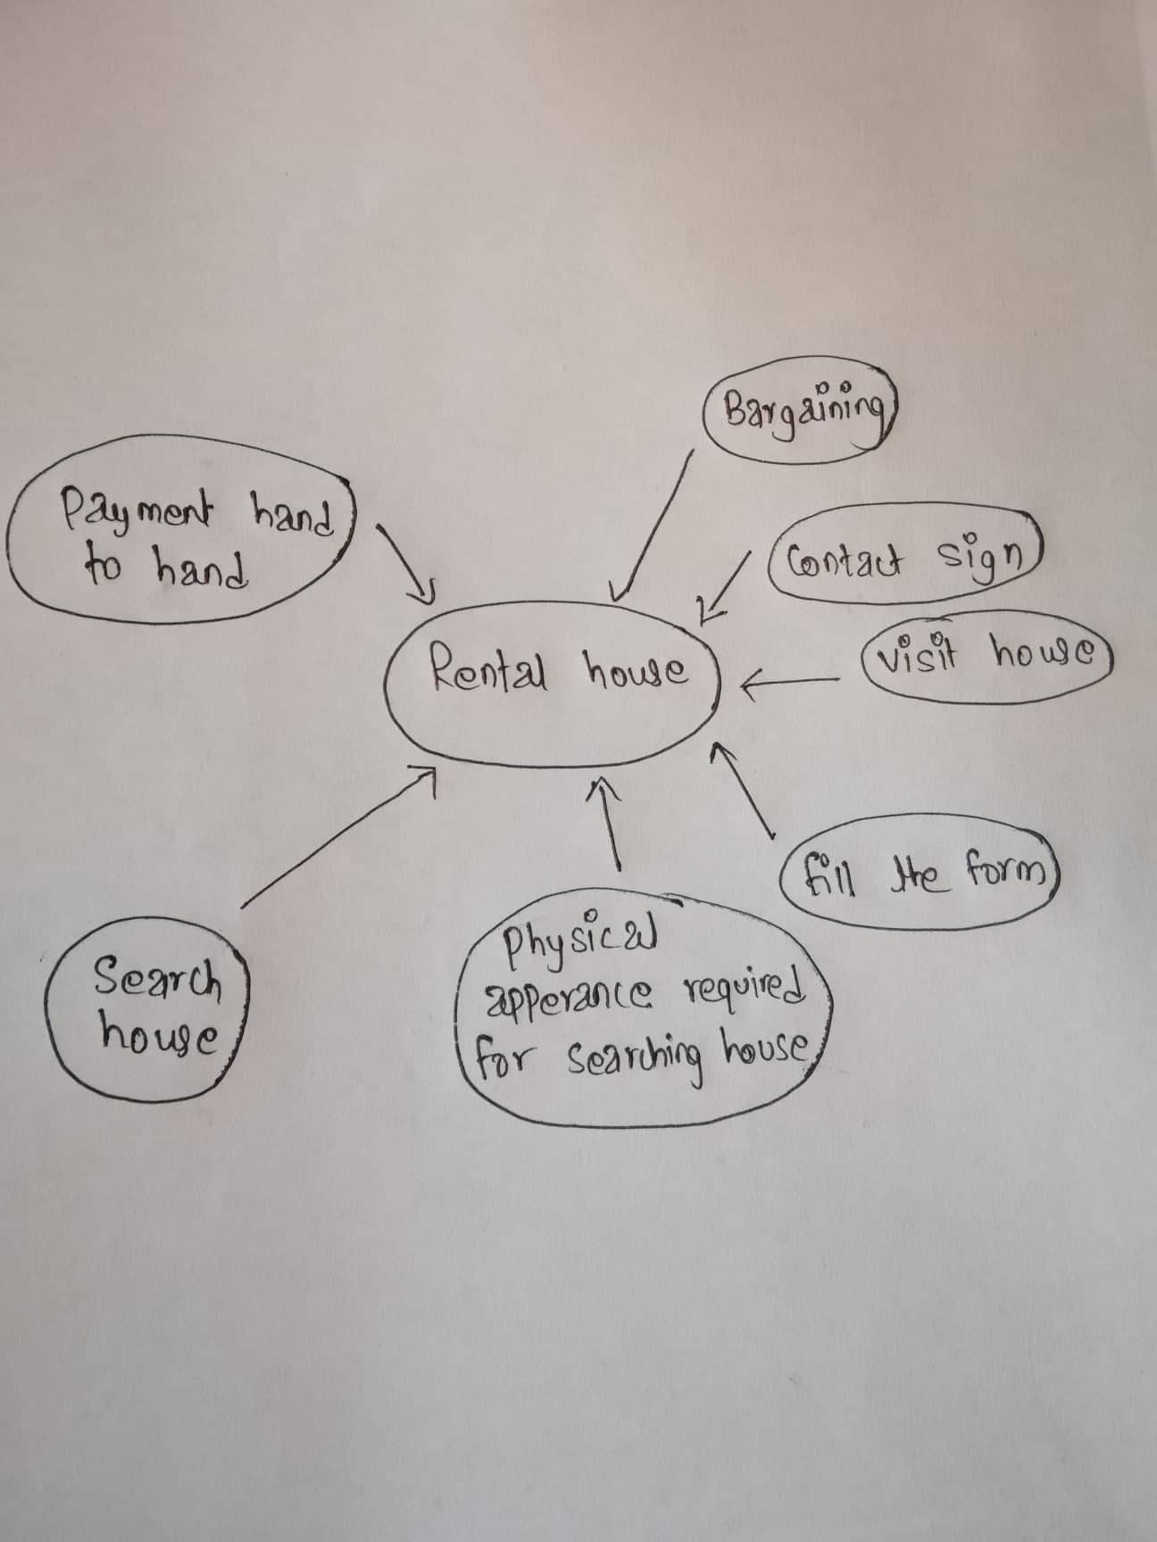

**Figure 1 Rich picture for house Rental Management system**

**CATWOE**

It is also the part of the SSM which can be used to encourage thinking about the problem and provide the appropriate solutions. It is also a problem solving method in which can be used to look at issues from six unique perspectives.

1. **Customer:** Customer or client is the users of the system and gets direct/indirect impact from the system. Also get effect or benefits if certain changes is made in the system. It is the 1st step in which the users first directly interact with the system by filling the registration form with their detail which is the customer for the system.
2. **Actor:** Those who are involved in the current situation (system). Actor may be in different form. For the current system Actor is Admin. Actor directly involved in solving the problem and making the new decision.
3. **Transformation:** It means what may be the effect of developing the system in current process. It considers the input and output from the system. The customer or users or clients should be able to use the system more easily and reliably. The current system is not reliable as it is manual, time and cost consuming. People have to be physically appear for searching the house and have to fill the paper form. This system is replaced by the system/application in which the customer and stakeholder can made the direct contact and conversation and customer can visit the property site and see the information online.
4. **World View**: It refers to the real world problem on system. It is also an overview of in and outside work which may influence in the development of the system. It include the prospective and view of the different persons on particular problem. Current system problem can be viewed in different way with different solution the owner and tenant have the different view on the same system as owner view from the business need and tenants may have view point to get the reliable facility in reliable cost. Also the users may have viewpoint that their property are rented properly and safely.
5. **Owner:** One who owns the system? For the current system/application admin user of the application is the owner who has the authority to make changes in the project. Decision making and future situation handling is also done by the owner (Admin).
6. Environment: In this step, there may be the different constrain and need to be aware of the demand of legal ,political, economic , social, technical which can disturbed the growing success of the system. These can be solved differently with different problem solving method.

**2.3 Feasibility study:**

Feasibility is one of the most important steps in software development. Feasibility study is the initial plane phase of any design which unites the component of the knowledge that indicate if the project is possible or not. Analysis and evaluation of the project is done to know if the project is technically, legally, socially feasible with in estimated cost, Solutions can be easily find if we know the project is not feasible in early stage of development.

Five types of feasibility which can be done in our project are describe bellow;

1. **Technical Feasibility:** Helps the organization to find the technical resources are useful for the project or not. Different types of software and hardware, technical team are determined and evaluated. My system/application is technical feasible as it can be run me mobile and computers.
2. **Economic Feasibility:** Means the financial transaction need or used in developing the system. Helps in managing and calculating the cost required in the system which helps to find whether costing for developing the system is high or not. If the cost is high then solution can be made by balancing the amount in time. As, the system helps to reduce the cost because they don’t have to visit the every place in search of house.
3. **Legal Feasibility:** This system fulfill all the legal requirement. Cannot get the copyright.
4. **Social Feasibility:** Can be consider as an important factor. If the developing system negatively impact the social environment then it will be not feasible to develop. My system is socially feasible as all types of people can use it there is no restriction for cast, culture, religion, color etc.
5. **Political Feasibility:** The developing system can make impact re effect in political parties. Developing system will not impact because all the parties can use it.

**Fact Finding Methodology:**

There are different types of technique and concept used for gathering the information. Information gathering is done at early stage of developing the system i.e. in analysis. Some of the information gathering method used in developing the system are;

1. **Questionnaires:**

It is the method in which the information are gathered by raising the question to the group of the people. Different or same question can be asked to the different person. Yes /no/multiple choice question should be asked in order to make them easy to answer. Some of the questions are;

Does the rental amount fit your budget?

Is the living area appropriate?

1. **Interview:**

It means the face to face communication with the interviewer. It is also one of the easy way of gathering information as personal view can be considerate at the same time by observing the interviewer facial expression.

**2.4 Software Requirement Specification (SRS)**

**Functional Requirement**

|  |  |  |  |  |  |
| --- | --- | --- | --- | --- | --- |
| **Id** | **Title** | **Description** | **Purpose** | **Dependencies** | **Impact** |
| **F1** | **Registration** | Self-description of the user is provided by themselves and new user is register. | To view the information and feature of the system used by the user. | **F2** | **Must have** |
| **F2** | **Login** | Login is done by only register users with verification | To securely access the system | **F1** | **Must have** |
| **F3** | **Search Property** | Customer/client can search their desirable (property) and can view the available property. | To find the desire property and to get the information of the property that already exist. | **F2,F4** | **Must have** |
| **F4** | **Add property** | Detail about the property are added for advertisement. | To know the detail or new information about the property advertisement. | **F2** | **Must have** |
| **F5** | **Edit property** | Certain changes can be made and maintained by the certain authorized person. | To add or update the old detail about the property which can be made by the user. | **F1, F2, F3** | **Must have** |
| **F6** | **Book property** | Clients can book the property if they find the suitable property. | Property shown in the advertisement can be booked. | **F2,F4, F3** | **Must have** |
| **F7** | **Delete property** | After the property is rented advertisement is deleted. | To deleted the advertisement of the rented property. | **F2,F3, F4, F5** | **Must have** |
| **F8** | **Send email** | Owner of the property are allowed to receive the email from each client. | In order to book the property by sending email. | **F2, F6** | **Should have** |
| **F9** | **Check advertisement** | Advertisement are managed by admin. | To keep only valid property advertisement or information of property. | **F2, F4** | **Should have** |
| **F10** | **Remove User** | User can be removed by the admin if they cat misbehaviourly/fake. | To maintain and manage the user. | **F2** | **Could have** |
| **F11** | **Post Blog** | Only the admin can post blog with specific tags. | Makes easier for users to search the details of the house by typing the specific given tags. | **F2** | **Should have** |

**Nonfunctional Requirement**

|  |  |  |  |  |
| --- | --- | --- | --- | --- |
| **Id** | **Title** | **Description** | **Proposes** | **Impact** |
| **NF1** | **Reliability** | System should not be failed during use. Should be run without any interruption. | Can be easily assess by any users. | **Must have** |
| **NF2** | **Performance** | Should be run fast and show the all detail in certain time. | Add ,edit and property function should be hide with in a sec. | **Should have** |
| **NF3** | **Availability** | Website should be available and can be used at any time. | Can be used by user from anywhere at any time. | **Must have** |
| **NF4** | **Usability** | User friendly interface is created. | User friendly and easy to access to the users. | **Must have** |
| **NF5** | **Scability** | Ability of a system to manage and grow the amount of work | To measure the growth of the user | **Should have** |
| **NF6** | **Capacity** | System/application can handle or store the data | To measure the collected data. | **Could have** |
| **NF7** | **Recovery** | Should be easily and fast recovery from any virus and error. | To prevent the previous data lose. | **Should have** |
| **NF8** | **Security** | Valid password and email of users is required to login | To prevent data loss and to maintain security of data. | **Must have** |
| **NF8** | **Error handling** | Appropriate message is provided to guide the users to solve the error | Essential of validation of users input. | **Could have** |

**Hard ware and software specification:**

**Hardware:**

Hard disk space: 256 mb

Ram memory: 4 GB

**Software:**

Operating system: windows 10, Windows 8

Database server: Xamp

Text Editor: Vs. code

**2.5 Use Case Diagram**

Use case can be explain as the graphic representation of the interaction of the users with the systems. Used in the analysis process as it helps to explain, identify the system requirement easily. Can be considers as a sets of actions which describe the whole systems functions.

Given diagram bellow shows the use case of house Rental management system.

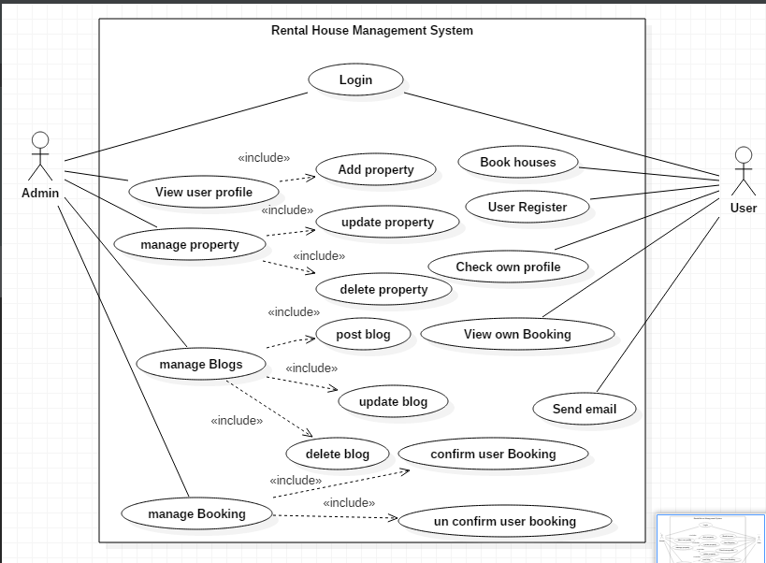

**Figure 2 use case diagram for house rental management system**

Above diagram represents the interactions of the admin and the users with the system. Admin are the persons who manage the whole systems and users are the website visitor who may be different in each time. Users have to login to the system in order to use the systems functions like booking. Website visitor/ users generally can view, search the property but cannot add and delete the property. Only the

Admin can delete, add and update the property. Admin can also post, update and delete the blog. Also has authority of confirm and UN confirm the users booking.

**Login**

Login functions helps to keep the system secure. Users and Admin have to login to the system by entering the correct email and password in order to use the system functions.

**Register**

Users need to provide the proper details in order to get register. Unique email should be provided.

**Add property**

It is process of adding the property to the system. By adding the different and more property users/ website visitor can select their desire property easily.

**Edit Property**

This process shows that any error in adding property can be corrected. Only the admin can edit the details of already added property.

**Delete property**

This process shows that already booked property can be deleted. Confusion in booking can be maintain by deleting the property which has been already booked.

**Booking**

Only the register users have the authority to book the property. One users can book only one property.

**Send Email**

Any website visitor/ users can send the email to the admin regarding the booking, complains, reviews etc.

**NLA**

Rental house management system is the system for management of the renting system of the house. House is the basic need to the people for living. So, to make the easy life style and easily accessible for all the people house rental system is introduce which can provide all the needed facilities. We also make it mobile friendly as, users can search for the reliable and vacant house and can transport any time. Tenants can search randomly according to their wish based on unique area and city.

**Identifications of noun and verbs:**

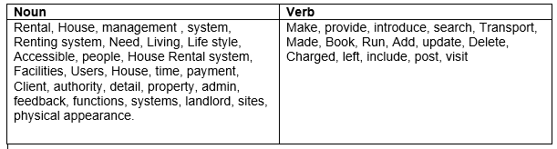

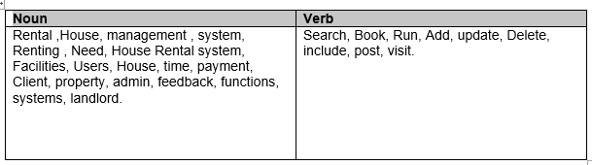

**Final classes are**

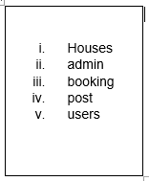

**2.6System Architecture:**

The system architecture that will be using for this project will be 3-tire. System Architecture is the conceptual model which only defines the structure, view and behavior of the system. The description of the whole system is done by this architecture. 3-tire is the flexible and faster the application. It is 3-tire structure is describe bellow.

1. **Presentation tire:**
2. **Application/Business tire:**
3. **Data tire:**

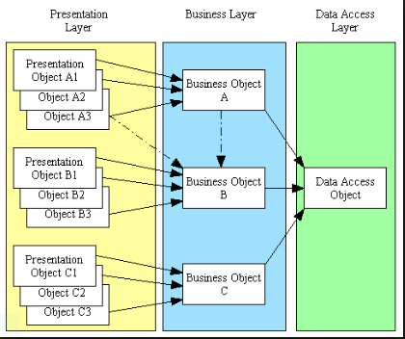

Figure 3-tier Architecture model

**Moscow prioritization**

Prioritization means giving the first importance to the required functional one. Moscow strategy is a priority technique used in the analysis, software development, and project management. It stands for must have, should have, could have and won’t have.

1. **Must have:** All the requirement should be fulfilled. If one function or requirement is miss or not completed then the project is failed. Without must have function the project can be consider as failure and cannot be deliver.
2. **Should have:** they are not as time critical and requirement can be replaced or fulfilled by other way.
3. **Could have:** Requirement are desirable and which may not be necessary. Can be used only for user’s experience and customer satisfaction. Without this requirement system can be easily run.
4. **Won’t have:** Functions which may be not required in present but can be planned and implemented in future for better system